How to prepare Irish climate data for Purls of Wisdom
You will need:
Access to a computer
An internet browser (for finding the websites)
Access to a data processing programme, like excel or google sheets
Some yarn, needles/hooks/other to get crafting with!

So what is it that we’re actually doing?
We’re finding, downloading, and sorting data into a way that we can use to make our finished works! We do this by working out the average climate value (could be any data available, from temperature to rainfall!) for the time periods you want to use, normally a year. Once we’ve worked out our yearly averages, we can compare these to the 30 year average to determine whether that year is colder or warmer than the average. This will determine the colour of that year! Simple… right?
I know that this tutorial will look very long and more than a bit daunting but I assure you that you are more than up to the task and can definitely do it! Just follow the steps laid out below and in our video tutorials, and if you struggle why not post a question on our Ravelry page?

Lets get started!

Step one: Determining your location
The locations we can work with are limited by weather stations that have 30 year averages available (Box 1), so the first thing we need to do is look for this information.
First things first, bring up your browser and go to www.met.ie. The webpage will look like below:
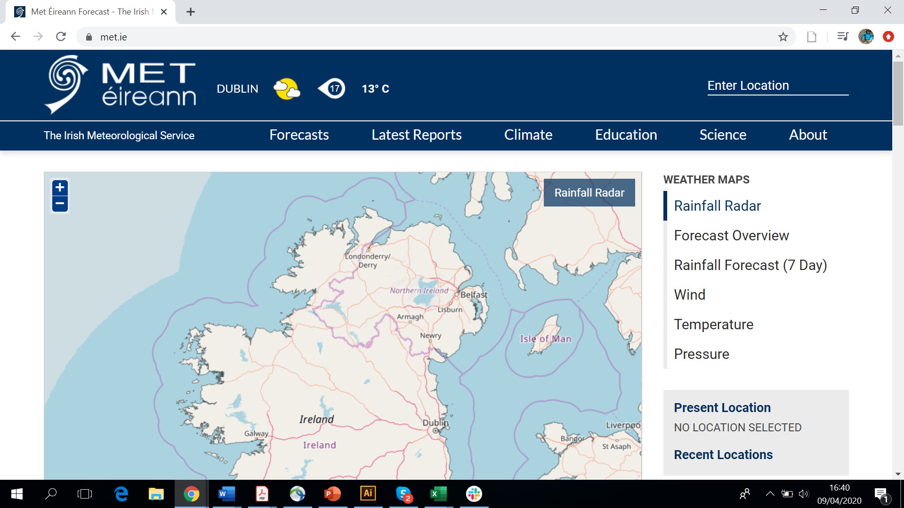
Once you’re there, go to the ‘Climate’ dropdown menu and choose ‘30 Year Averages’
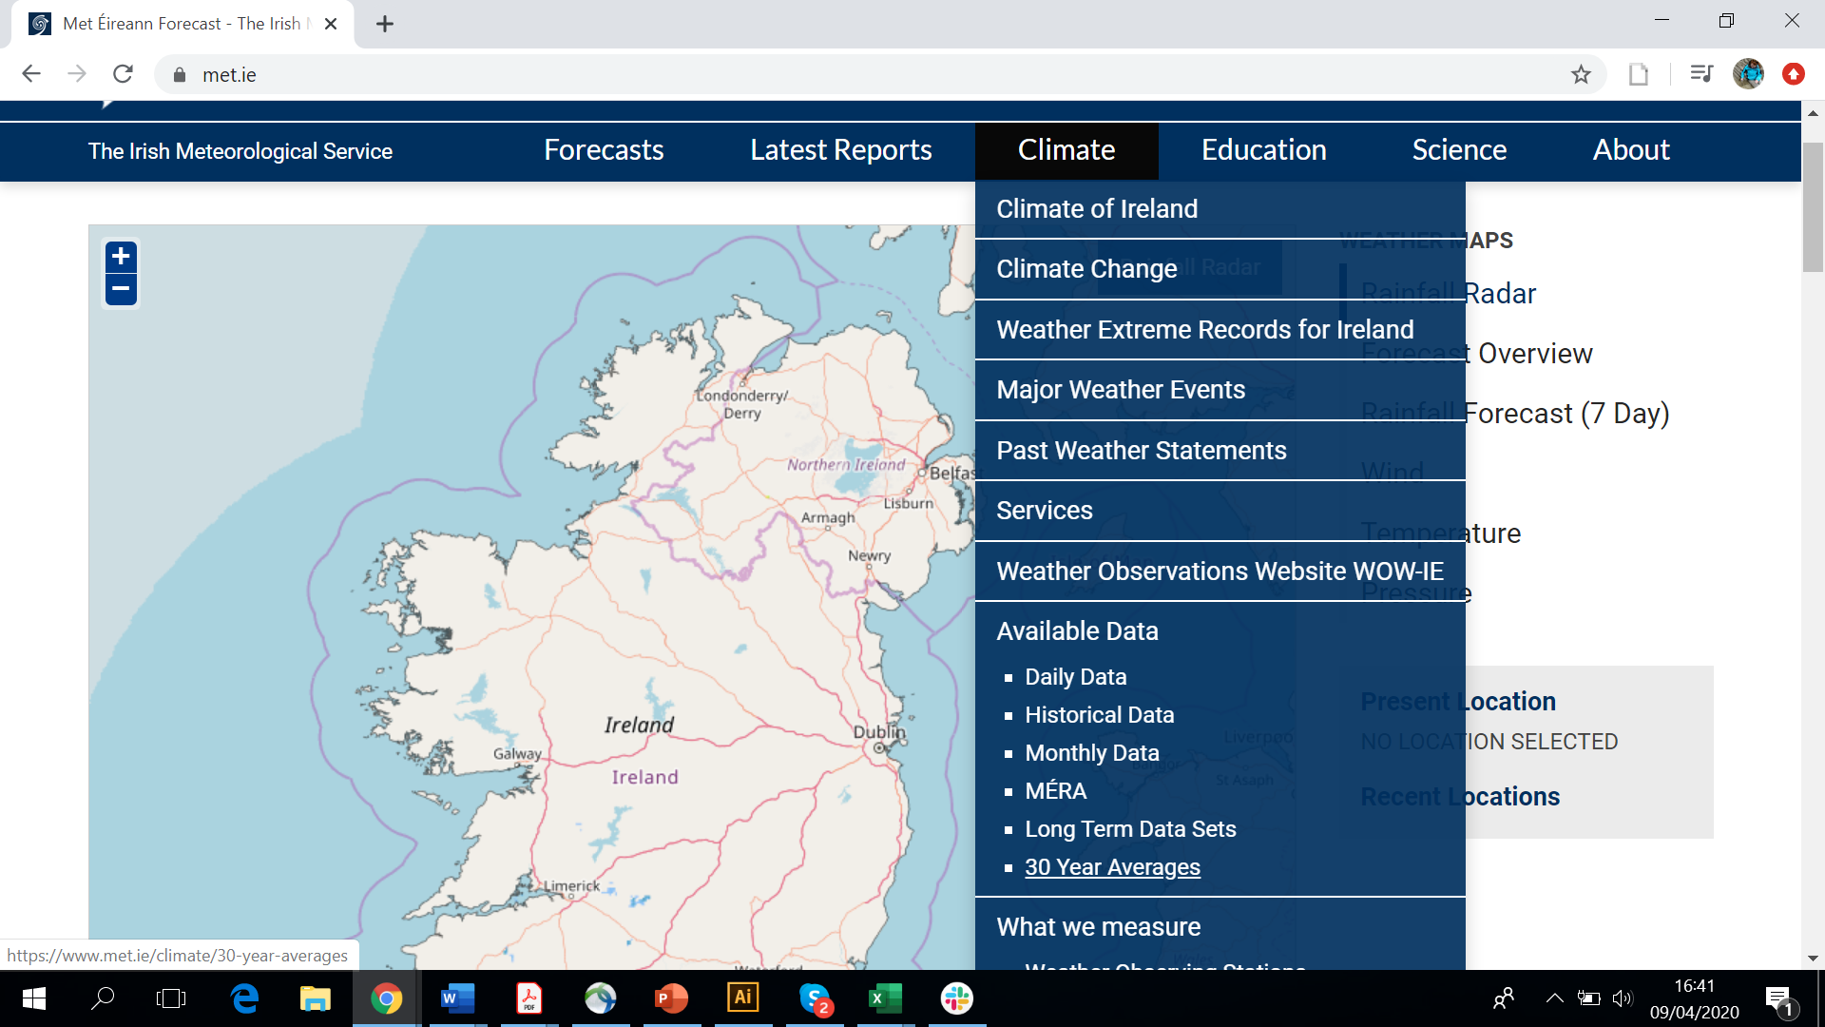
We can now see that the most recent 30 year averages are available for 12 places:
- Belmullet
- Birr
- Casement
- Clones
- Cork Airport
- Dublin Airport
- Kilkenny
- Malin Head
- Mullingar
- Rosslare
- Shannon Airport
- Valentia
For this example, we’re going to use Dublin Airport.
When you click into your location, you can see that there’s a lot of data available!
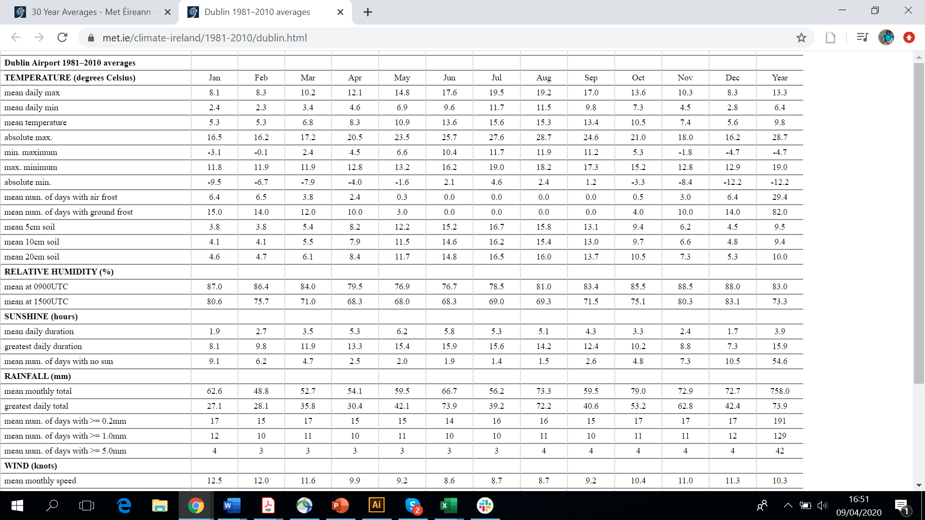
Lots of data!
You can choose just about any of these, whatever is interesting or important to you. Temperature is always a good one to choose as it’s the one that comes to most people’s mind when you mention ‘climate change’, but its really up to you! Let’s use mean temperature in this example.
As you look across the top of the table on the webpage, we can see the time periods (Box 2) that the values for the climatic parameters have been recorded for. The time period that we’re interested in is yearly, so we can ignore everything apart from the Year value. The number that we need to remember in our example case is 9.8.
Now we need to find and download our raw data. This is raw, unaltered data that has been directly recorded by Met Eireann. Lets go back to our ‘Climate’ dropdown menu and find the ‘Historical Data’ option.
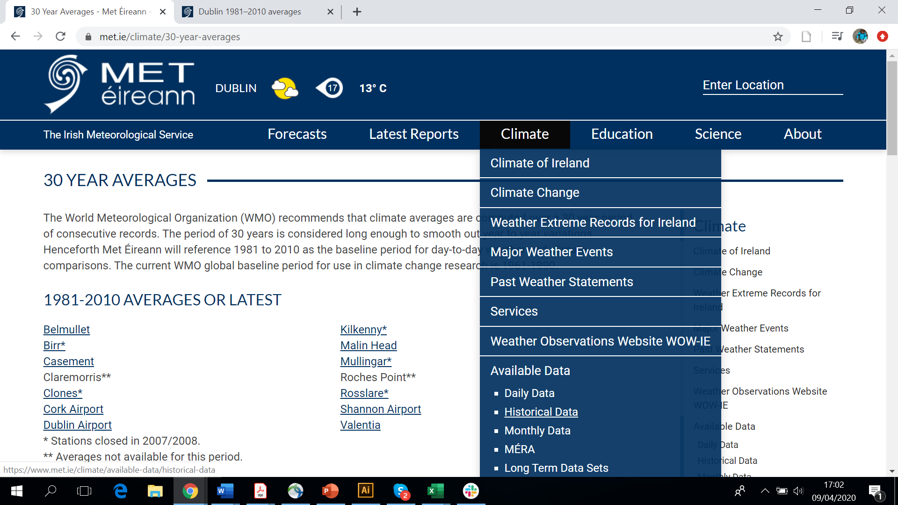
Once you’re on the Historical Data page, you can see that we need to choose a data resolution. The easiest resolution to work with is Monthly, so lets choose this. We can then enter the county we’re interested in and find the correct weather station (remember, this needs to be one of the ones with 30 year averages available). 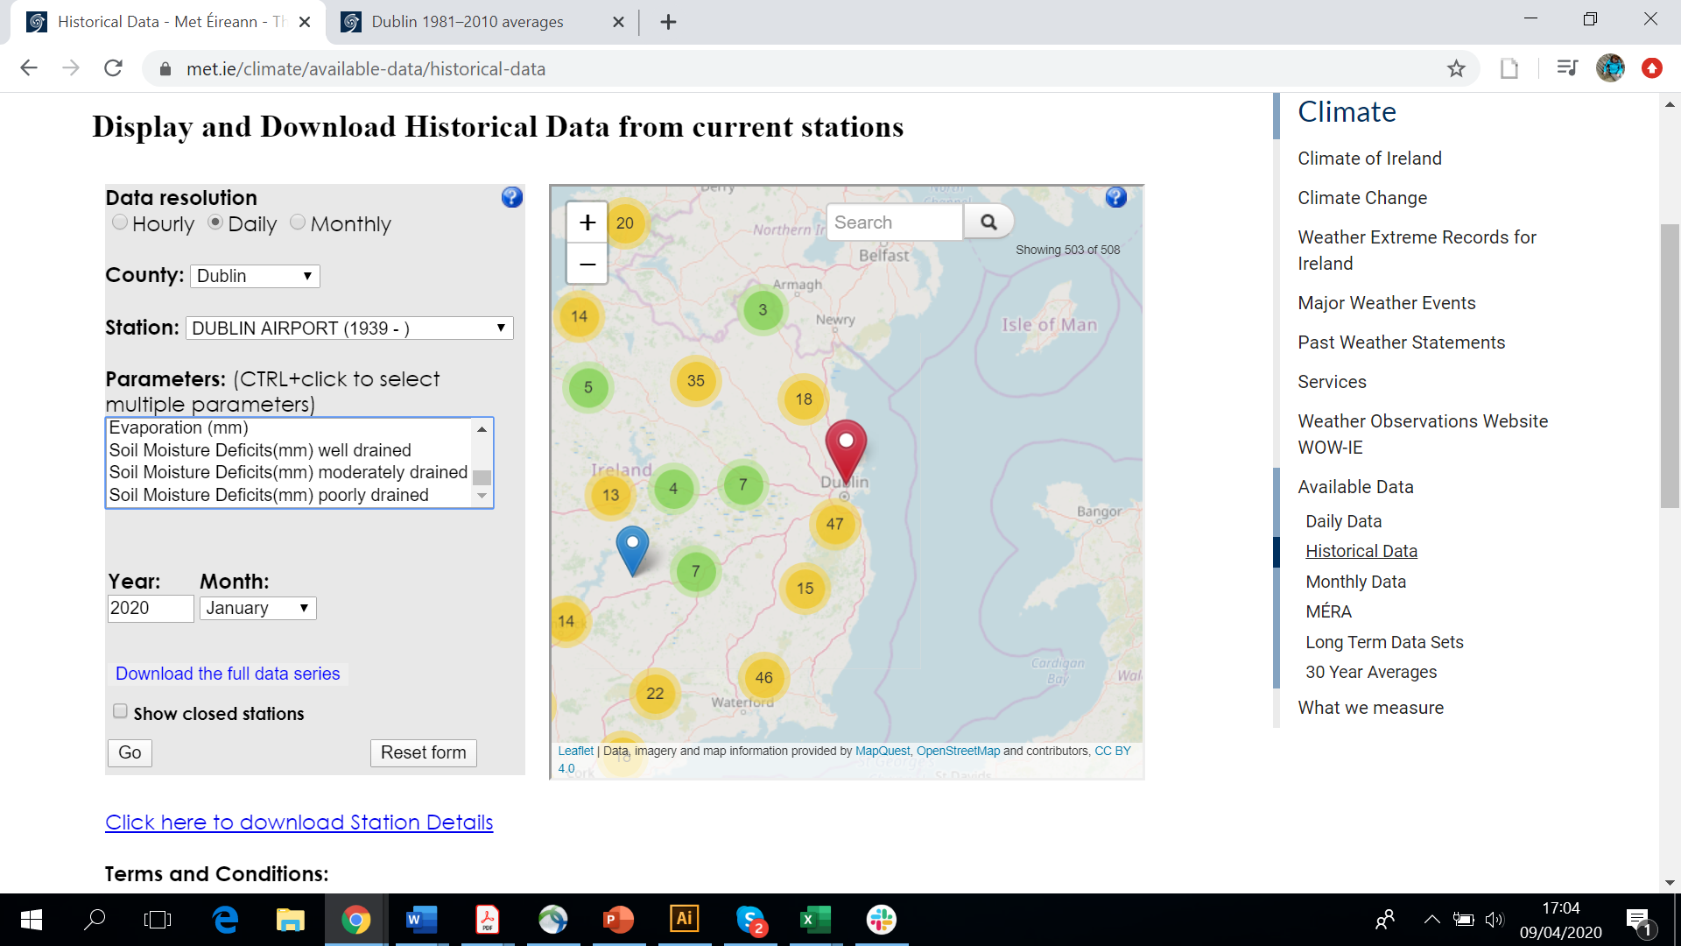
Lots of parameters will now become available. Click on the one you’re interested in and then click on ‘Download the full data series’ (the Year box doesn’t matter, so just leave be).
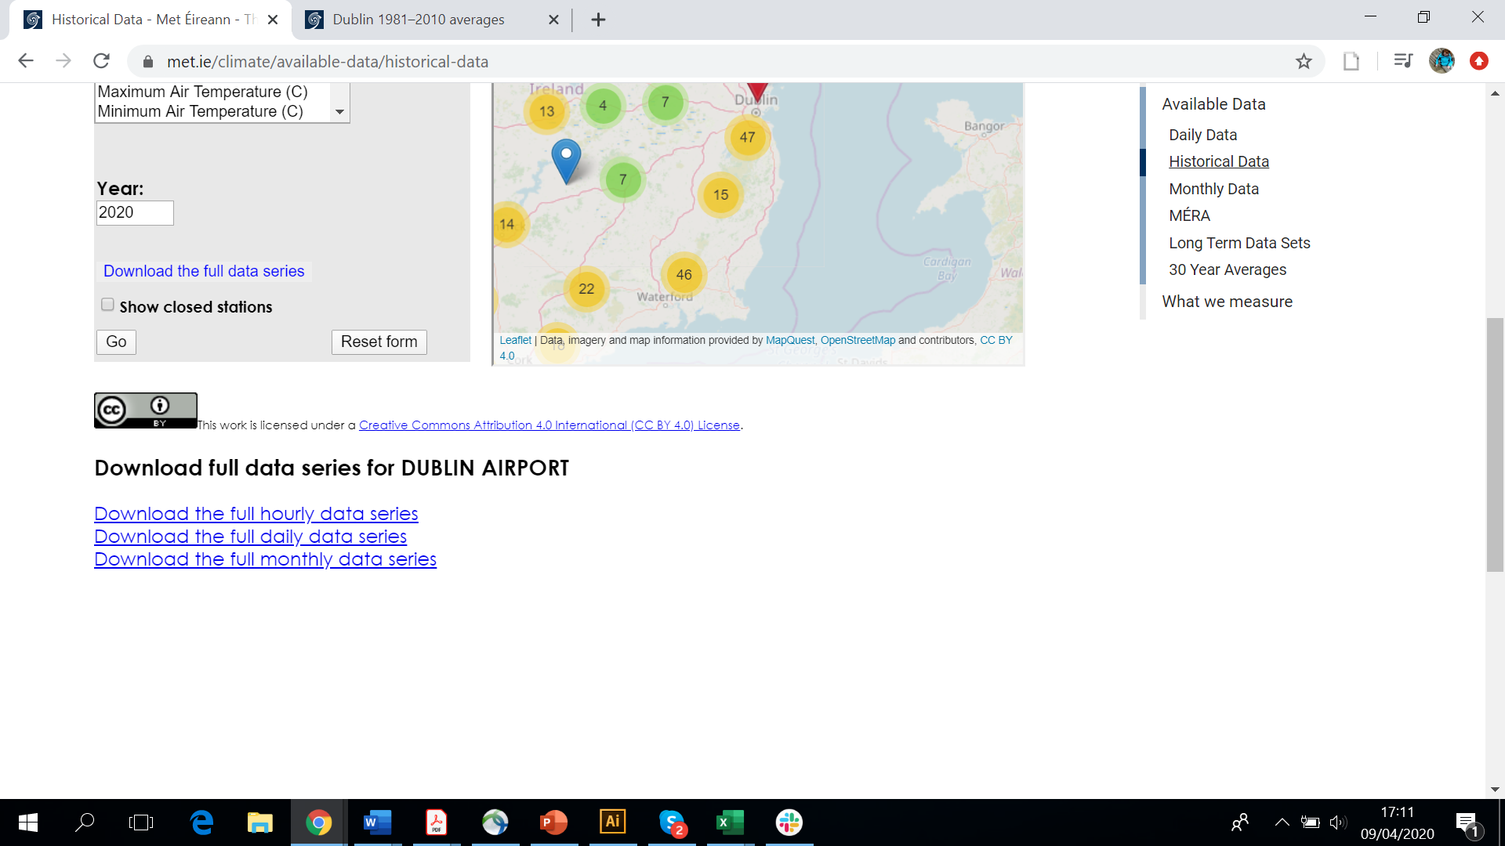
Three links will now have popped up, we need to click the ‘Download the full monthly data series’ which will download the data that we want to work with!
Step 2: Working with data
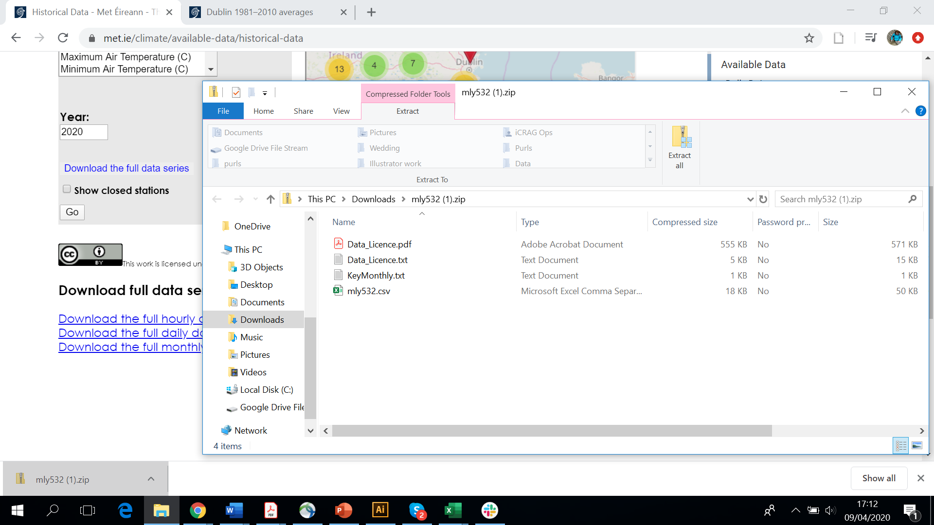
When you open up the folder that you’ve downloaded, you can see that there’s four files in there. The one that we’re interested in is called ‘mly532.csv’. Lets open that up with our data processing programme, in this case I’m going to use Microsoft Excel. Tip: If you right click on the file, you can tell the computer which programme you want to use to view/work with the data by using the ‘open with…’ option.
Once the data is open, it will look like this:
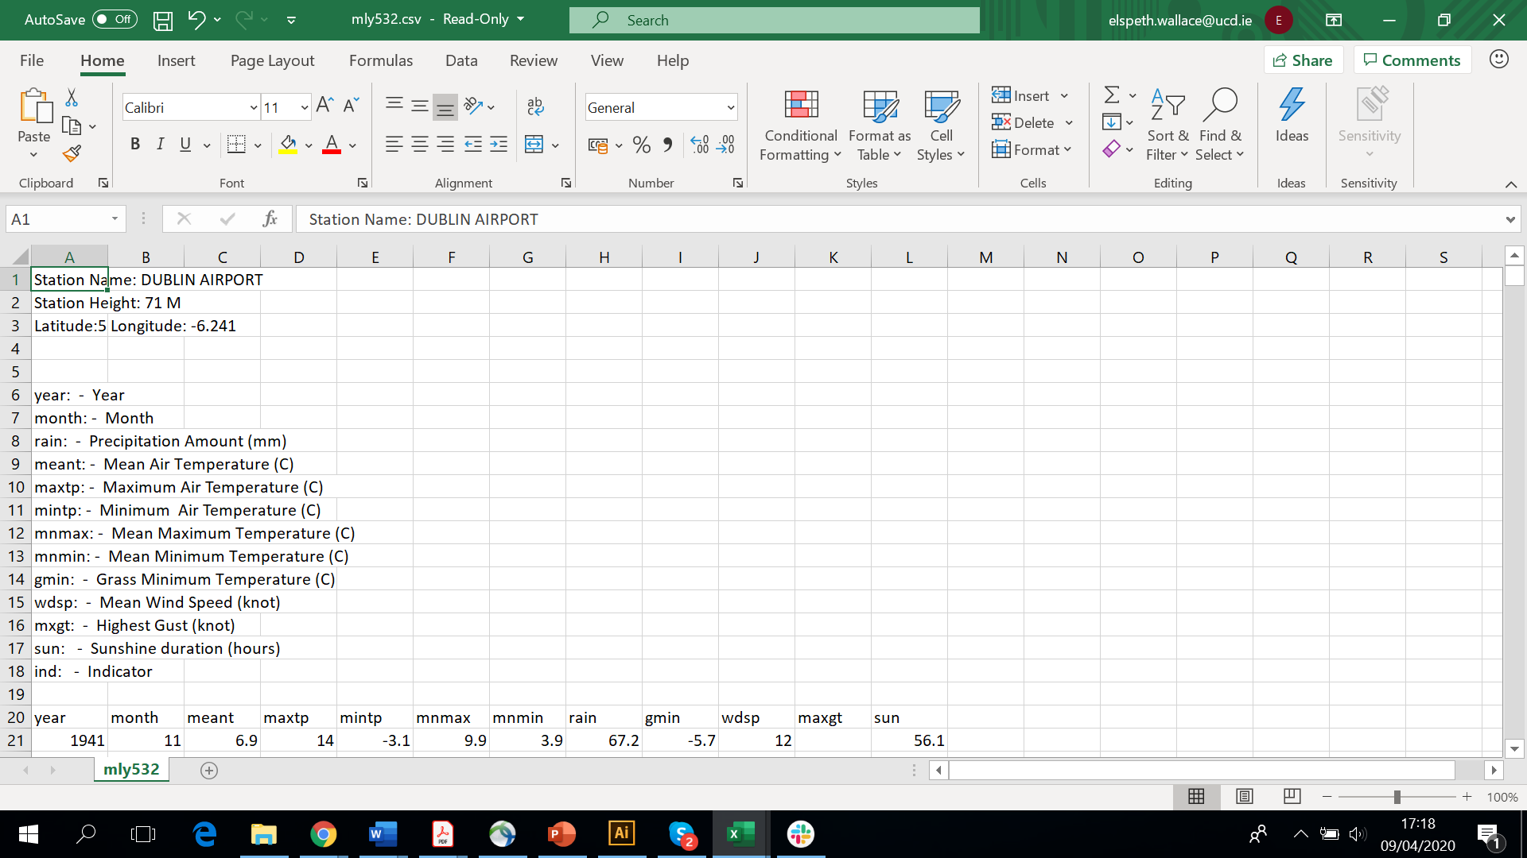
The information at the very top left gives you some more information about the Dublin Airport weather station. Underneath this is a list of explanations for the abbreviations that are on top of the data columns. We’re interested in mean temperature in this example, so we need to look for ‘meant’ column which is in column C.
Lets have a quick look through the data. We can see that on the very left, we have the year that the data was recorded in (column A), with the month in the year that the data was recorded next to it (column B). At this point it’s a good idea to clean up the data a bit. Remember, we’re going to be using the data to calculate a yearly average. To calculate a yearly average, you need a years worth of recorded data. In this example, we can see that 1941 only has two values recorded and 2020 only has one. Lets get rid of these rows by highlighting them (click on the leftmost cell and drag across or press and hold ‘shift’ whilst pressing your right arrow key a few times) and clearing their contents (right click with the mouse and select clear contents).
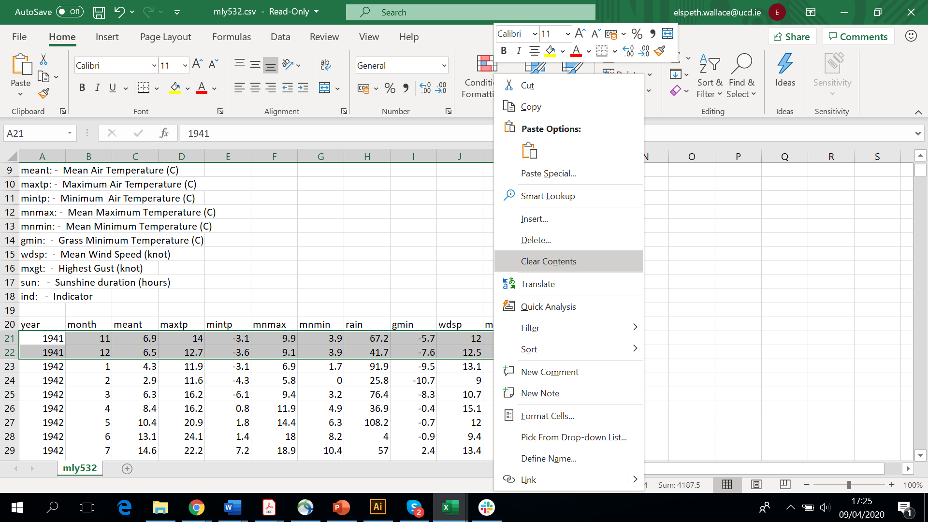
Now, just to tidy it up a bit, lets move the numbers up to be right under the headings by highlighting them all, right clicking and selecting ‘cut’ then clicking in the cell under ‘year’ (cell C21) to select it and the right clicking on it and selecting ‘paste’.
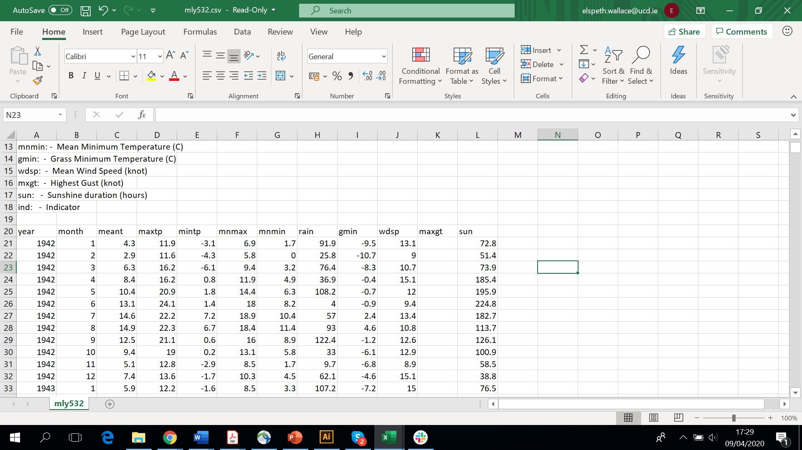
Now lets get rid of the data that we don’t need. We can highlight all the columns to the right of the ‘meant’ column and then right click them and clear their contents.
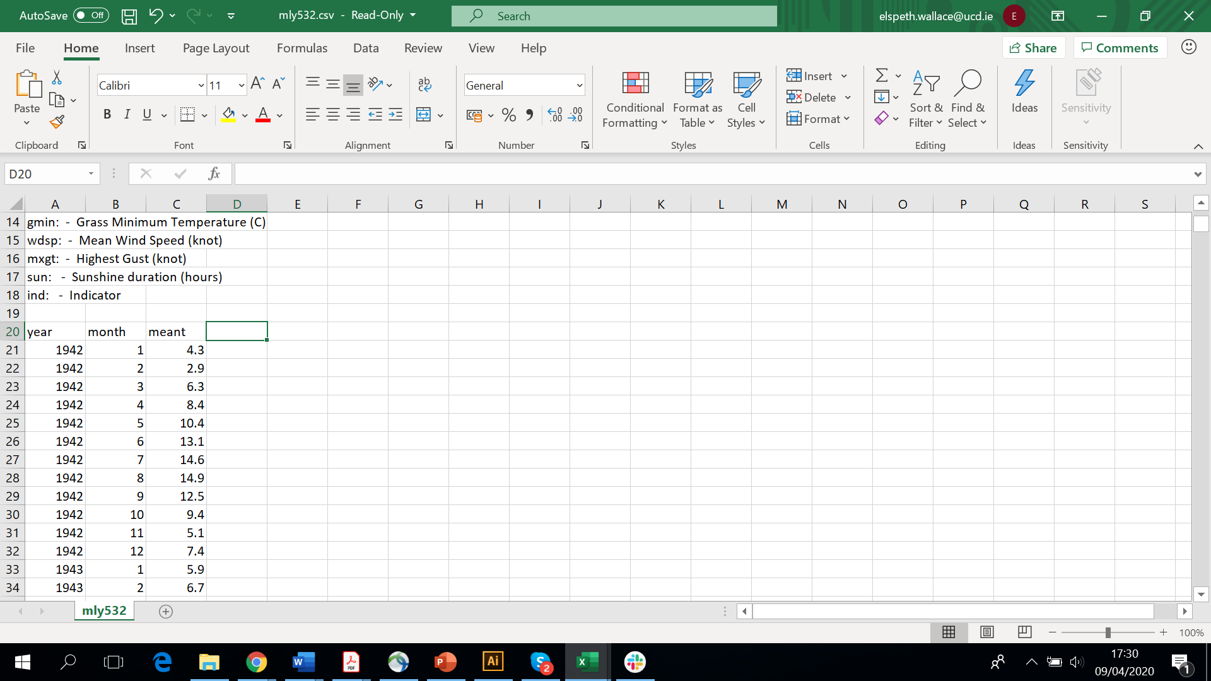
Now we’ve got the data we want to use sorted out, lets get it sorted into the right format!
Remember, we want to work out a yearly average value for our meant. We can all remember that to work out the average we need to divide the sum of the numbers by the number of numbers:
INSERT MEAN FORMULA HERE
To make things easy for ourselves, lets make a few new columns. (You can copy and paste what’s below if you like).
Year | Sum of meant | Number of months | Mean meant

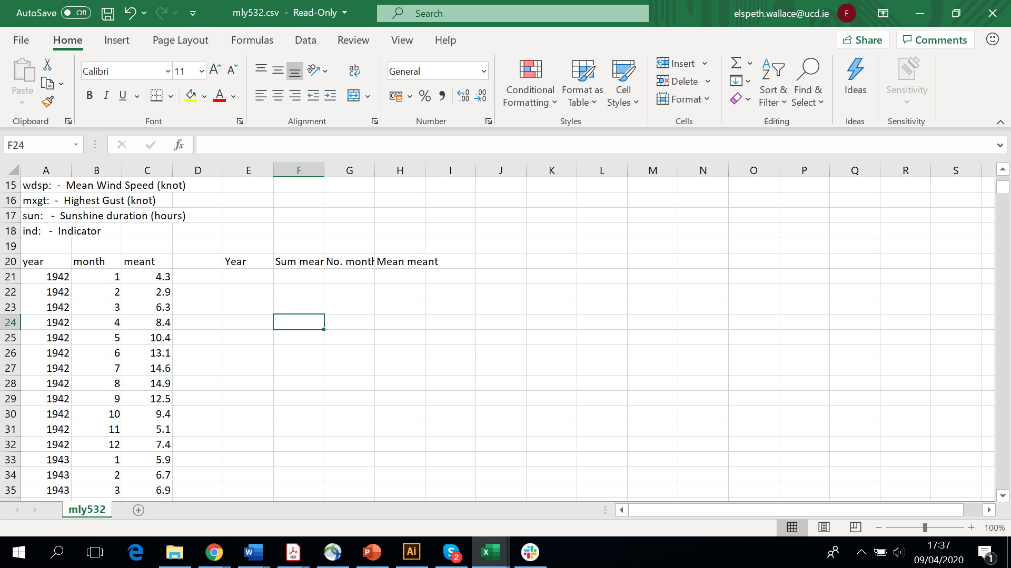
Our data runs from 1942 to 2019, so lets fill these numbers into the year column.
Start by typing 1942 into the cell underneath ‘year’. In the cell below it type the following formula =E21+1 and then press enter. Your cell should now have 1943 in it! Congratulations, you’ve inputted the first formula into our spreadsheet!
Now we’re going to use a fantastic tool called the fill handle. This tool is used to copy a value/formula/series down or across a column or row. To use it, all you need to do is hover over the bottom right of a cell. Can you see how the pointer has changed into a black cross? When your pointer looks like that and you’re hovering over the cell you want to work with, you click and drag across or down and excel will copy the formula that’s in the cell into the cells you highlight.
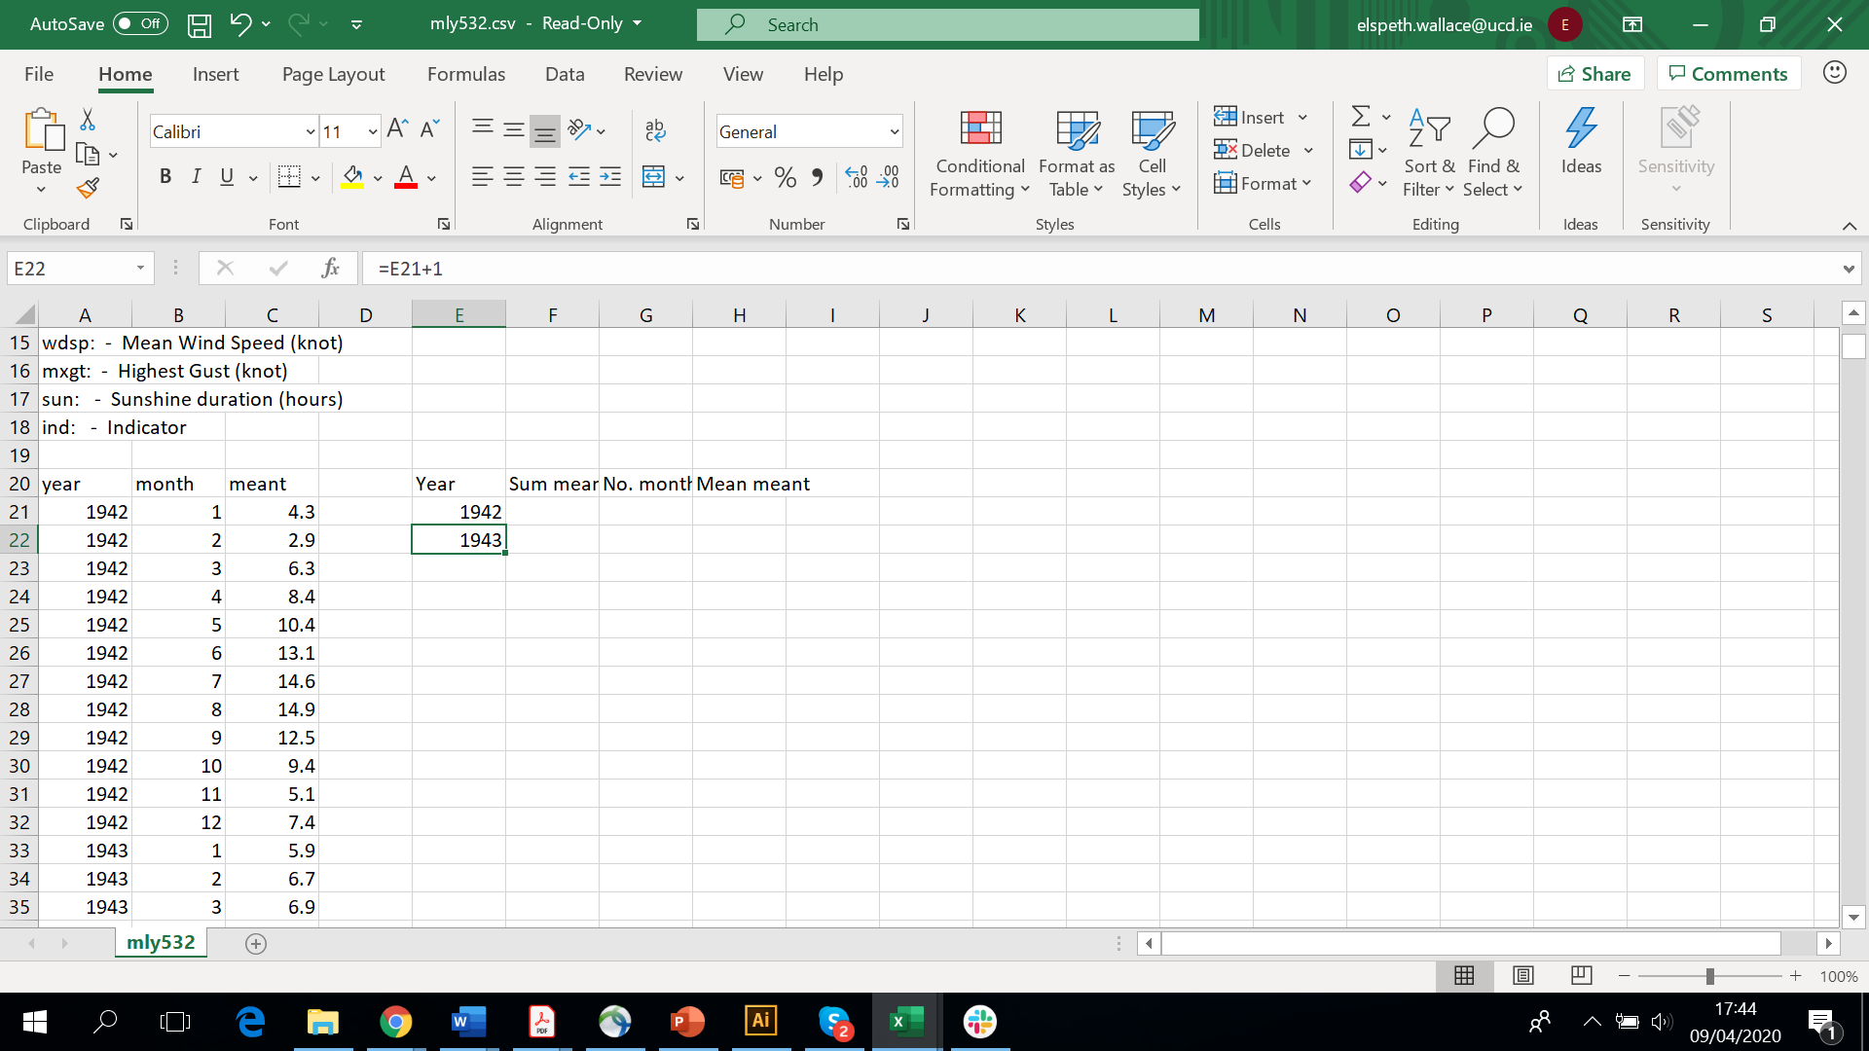
In our case, we need to use the fill handle on the cell that we just typed out formula in. Drag the fill handle down until you are given the value 2019.
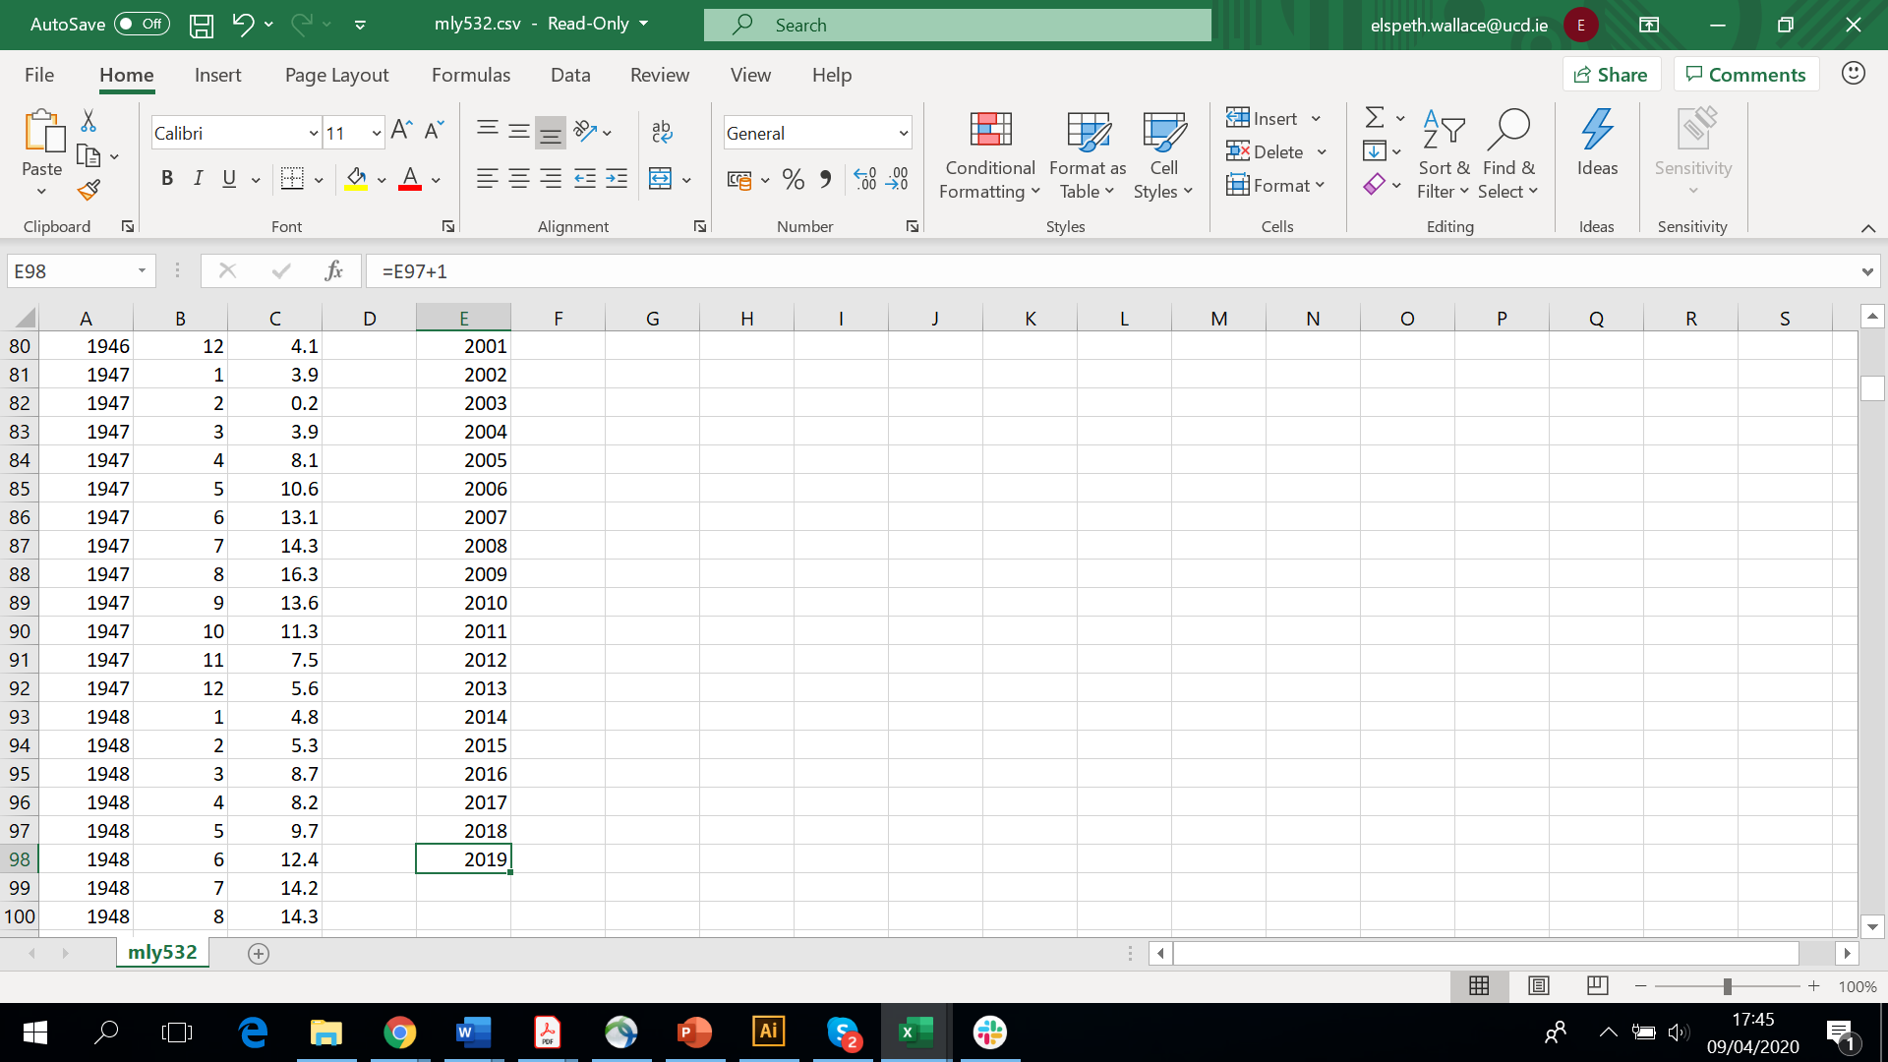
Now lets fill in our ‘No. Months’ column. Surprisingly enough, all years have 12 months in (I know right!), so lets put this in all of the boxes down to the same row as the year 2019. We can do this easily by inputting ‘12’ into the cell beneath ‘No. Months’ and using the fill handle to fill the boxes below. Remember, hover over the bottom right corner until the black cross appears, and then click and drag down to the right row (row 98 in our case).
Here’s where the tricky bit is. We need to work out the sum of all the values for ‘meant’ in one year. We can do that in one of two ways. The easiest way, but most time intensive way is to use a sum function once per year to add up the ‘meant’ values in a year. As this requires inputting a formula in for every single year and we’re working with 80 years, I tend to use a different method that’s a little more difficult to input, but is much quicker and easier to work with after the initial input. I’ll go through both methods below:
Method one: The sum function (easy to input, but very time intensive).
- Click in the cell and type in =SUM At this point, you’ll notice that a drop down of formulas that excel thinks you might want to use pops up. Double click on the SUM function. The formula =SUM( will now have appeared.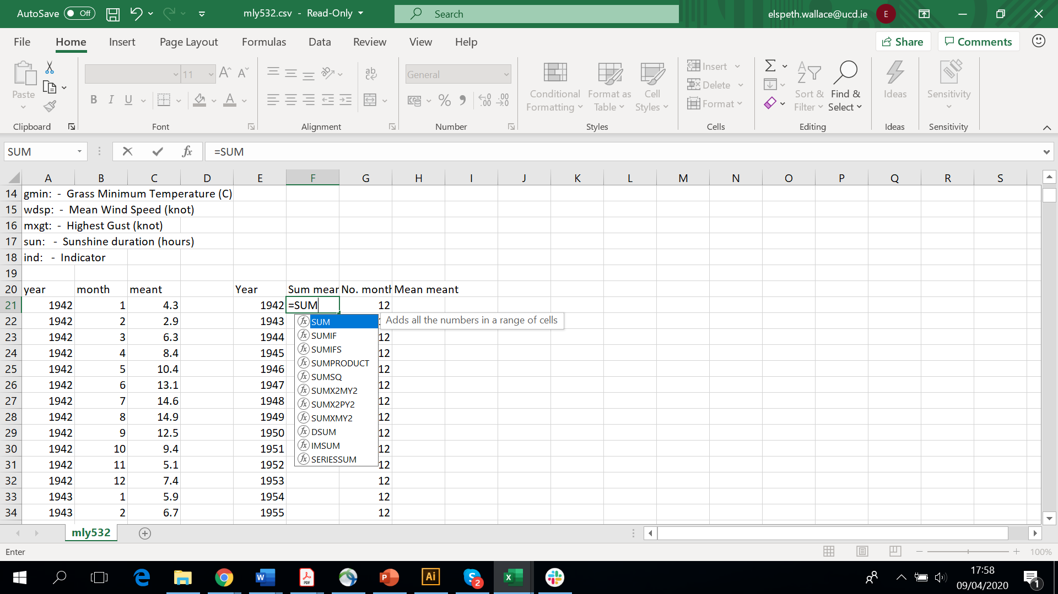
- Now we need to tell excel which values we want it to add up. We can do that by clicking in the topmost cell we want it to add up and dragging the mouse down to the bottom cell we want to add up. This will now have changed the formula in the cell to =SUM(C21:C32)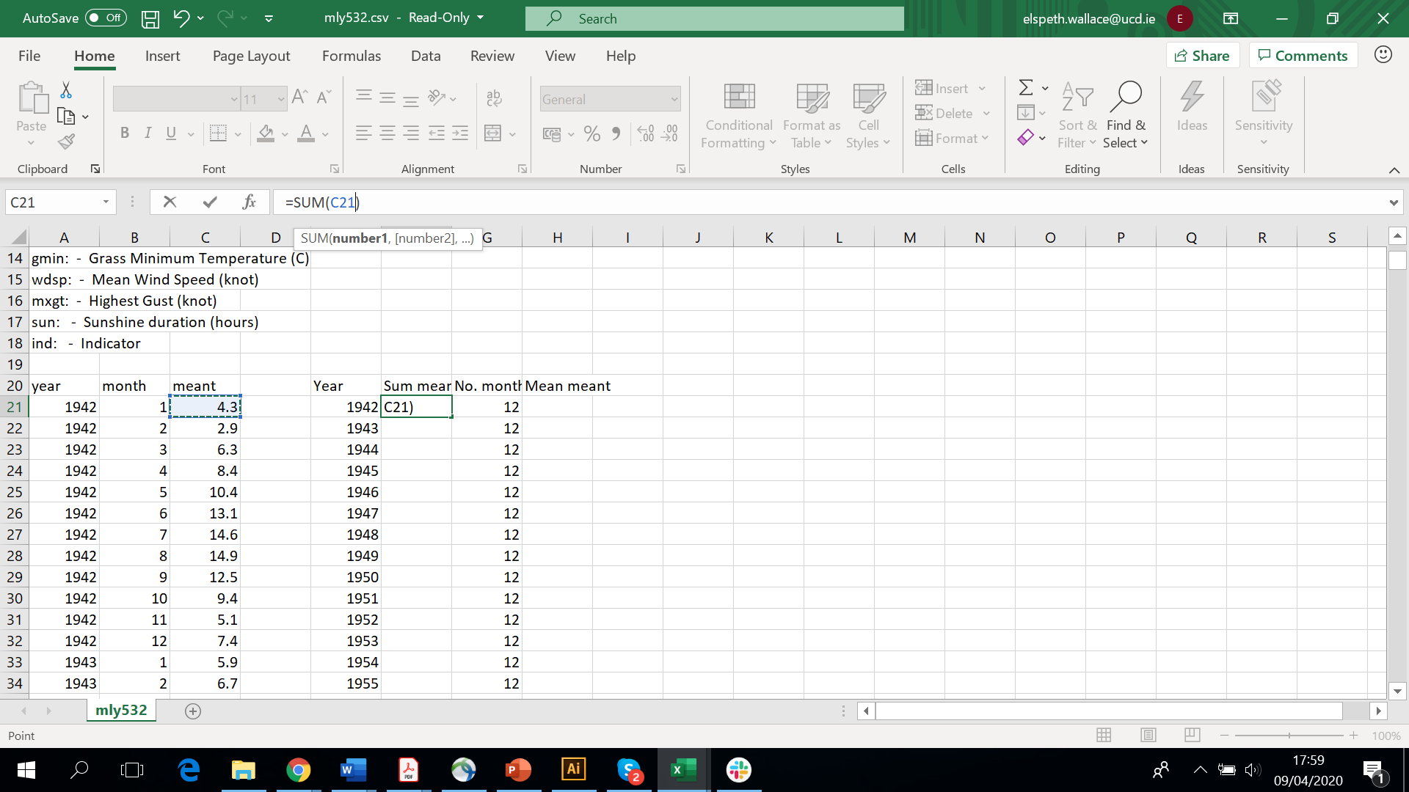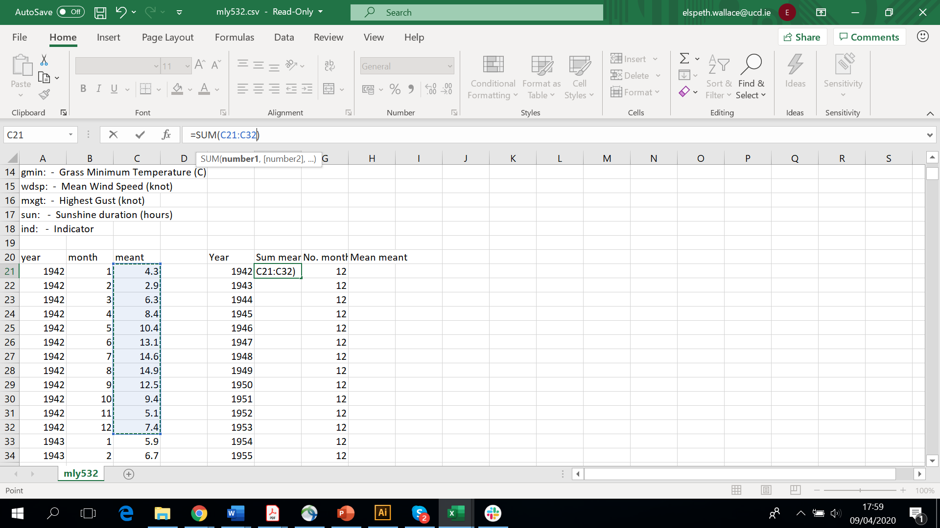
- Hit enter, and the sum of ‘meant’ for 1942 has been calculated!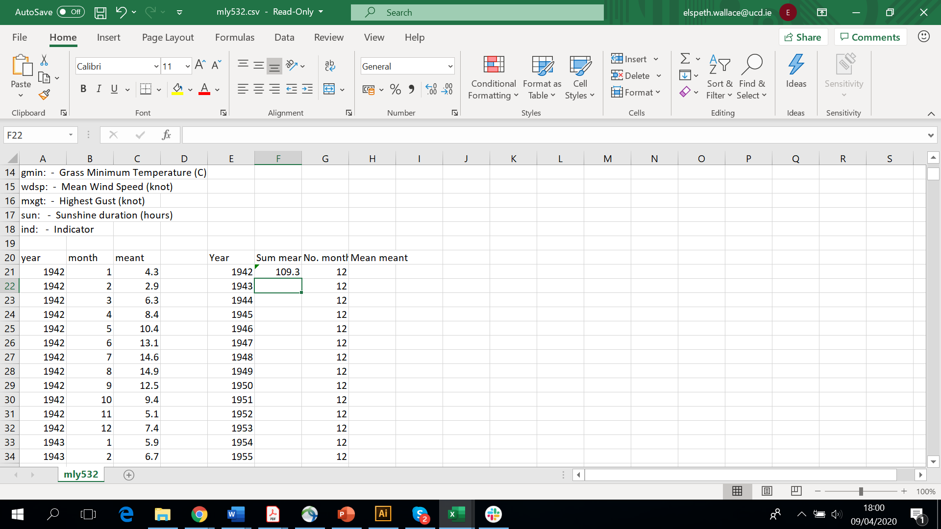
- Repeat for each year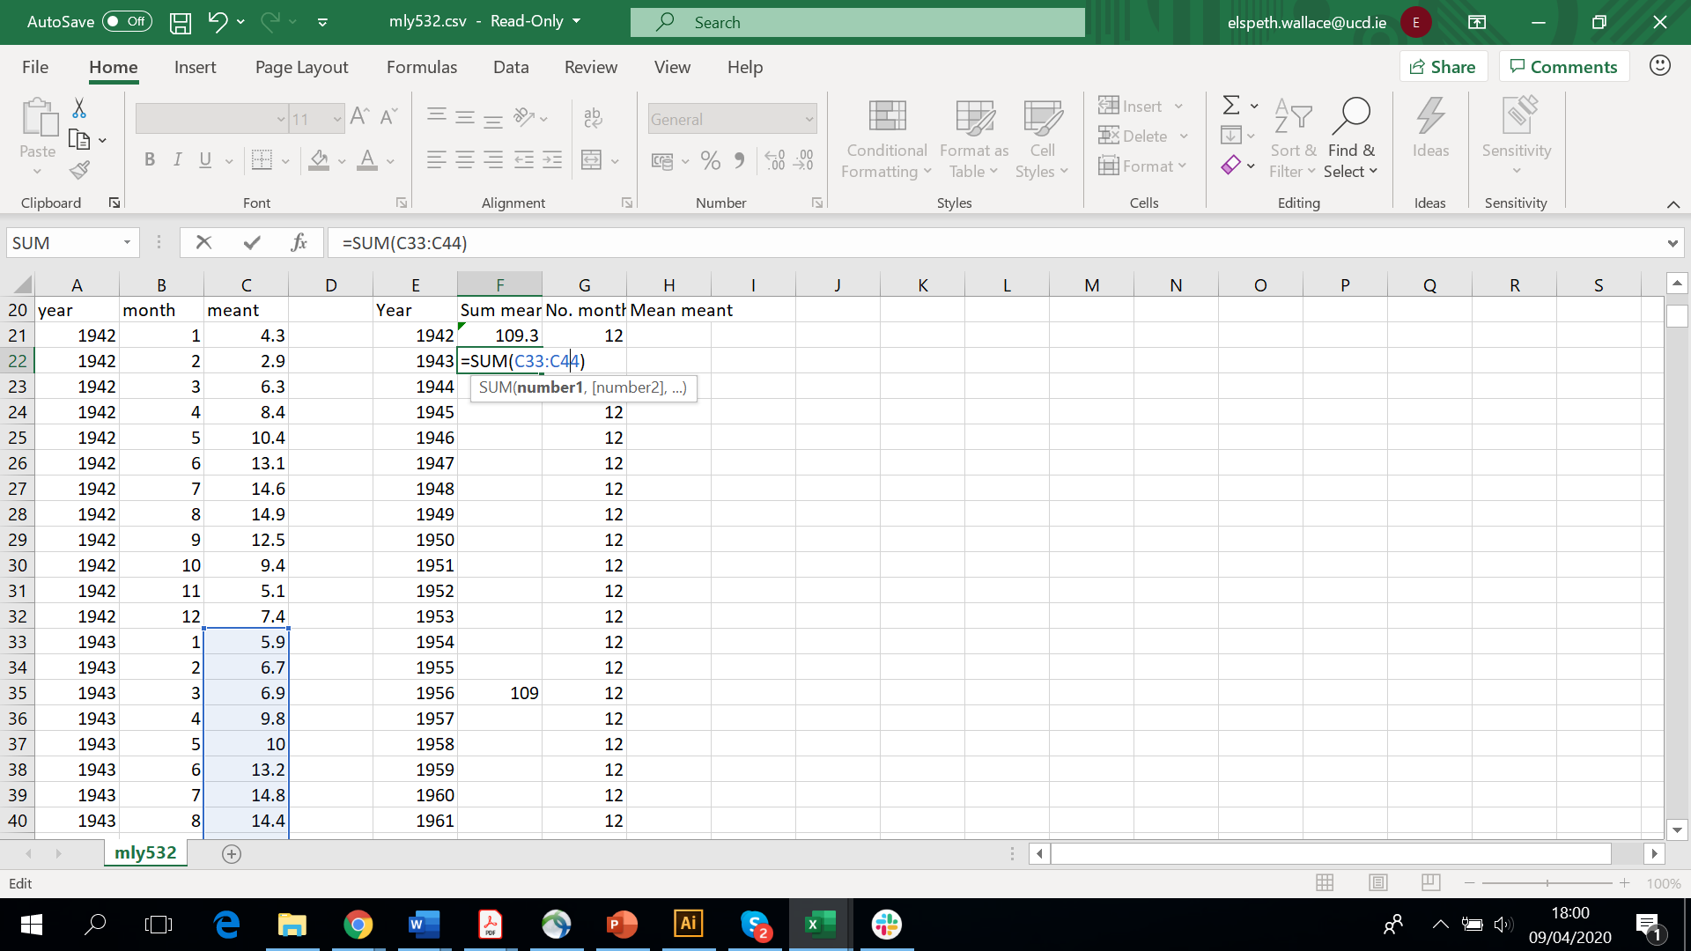
Method 2: More difficult to input, but much easier in the long run!
There’s two steps to this method, inputting a formula to make excel add up all the values in 12 cells, then using the fill handle to make excel repeatedly do this (basically, it adds up all the values in every 12 cells). Might sound a bit strange and difficult, but its actually really easy, bear with me!
- Click in the cell under ‘Sum meant’ (it is C21) and type in the following formula EXACTLY
=SUM(OFFSET($C$21,(ROW()-ROW($C$”!))*12,0,12,1))
This will add up all the values in the first 12 cells, using cell C21 as its starting point. 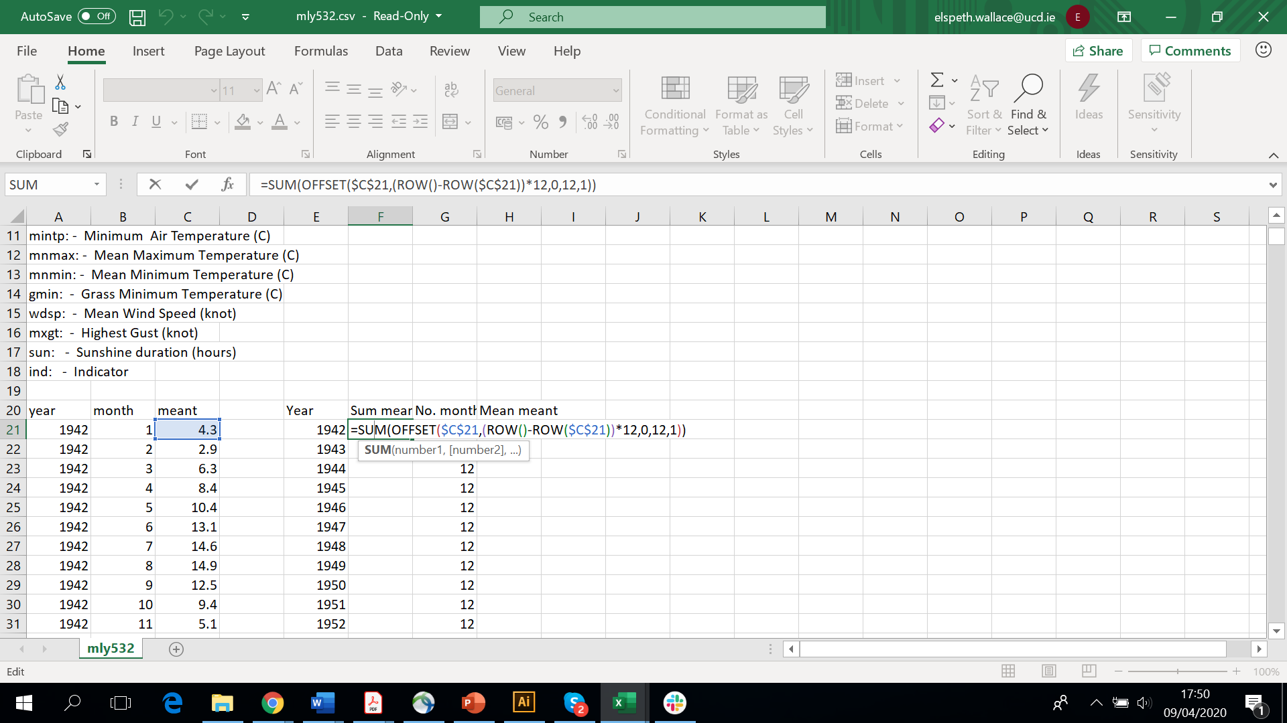
- Use the fill handle to copy this down to the bottom. 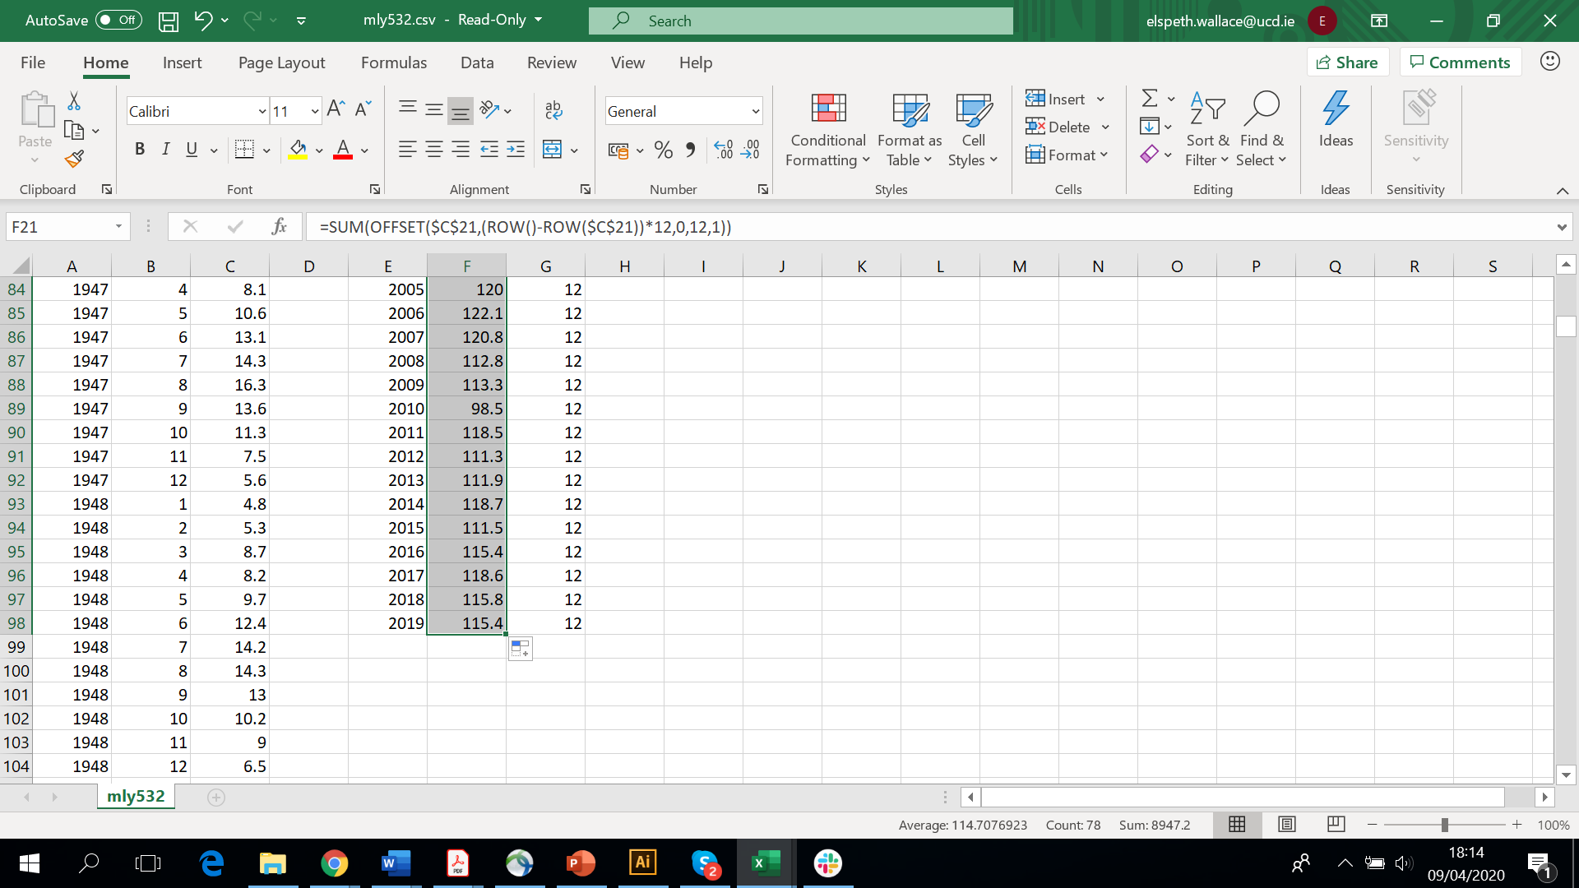

Finally, lets work out our yearly average. To do this, we need to divide our sum meant column by our month column. Click in the cell under Mean meant and input the formula =F21/G21 (or type = and click F21 type / and click G21) and press enter. Use the fill handle to calculate the means for each row (drag down to 2019!).
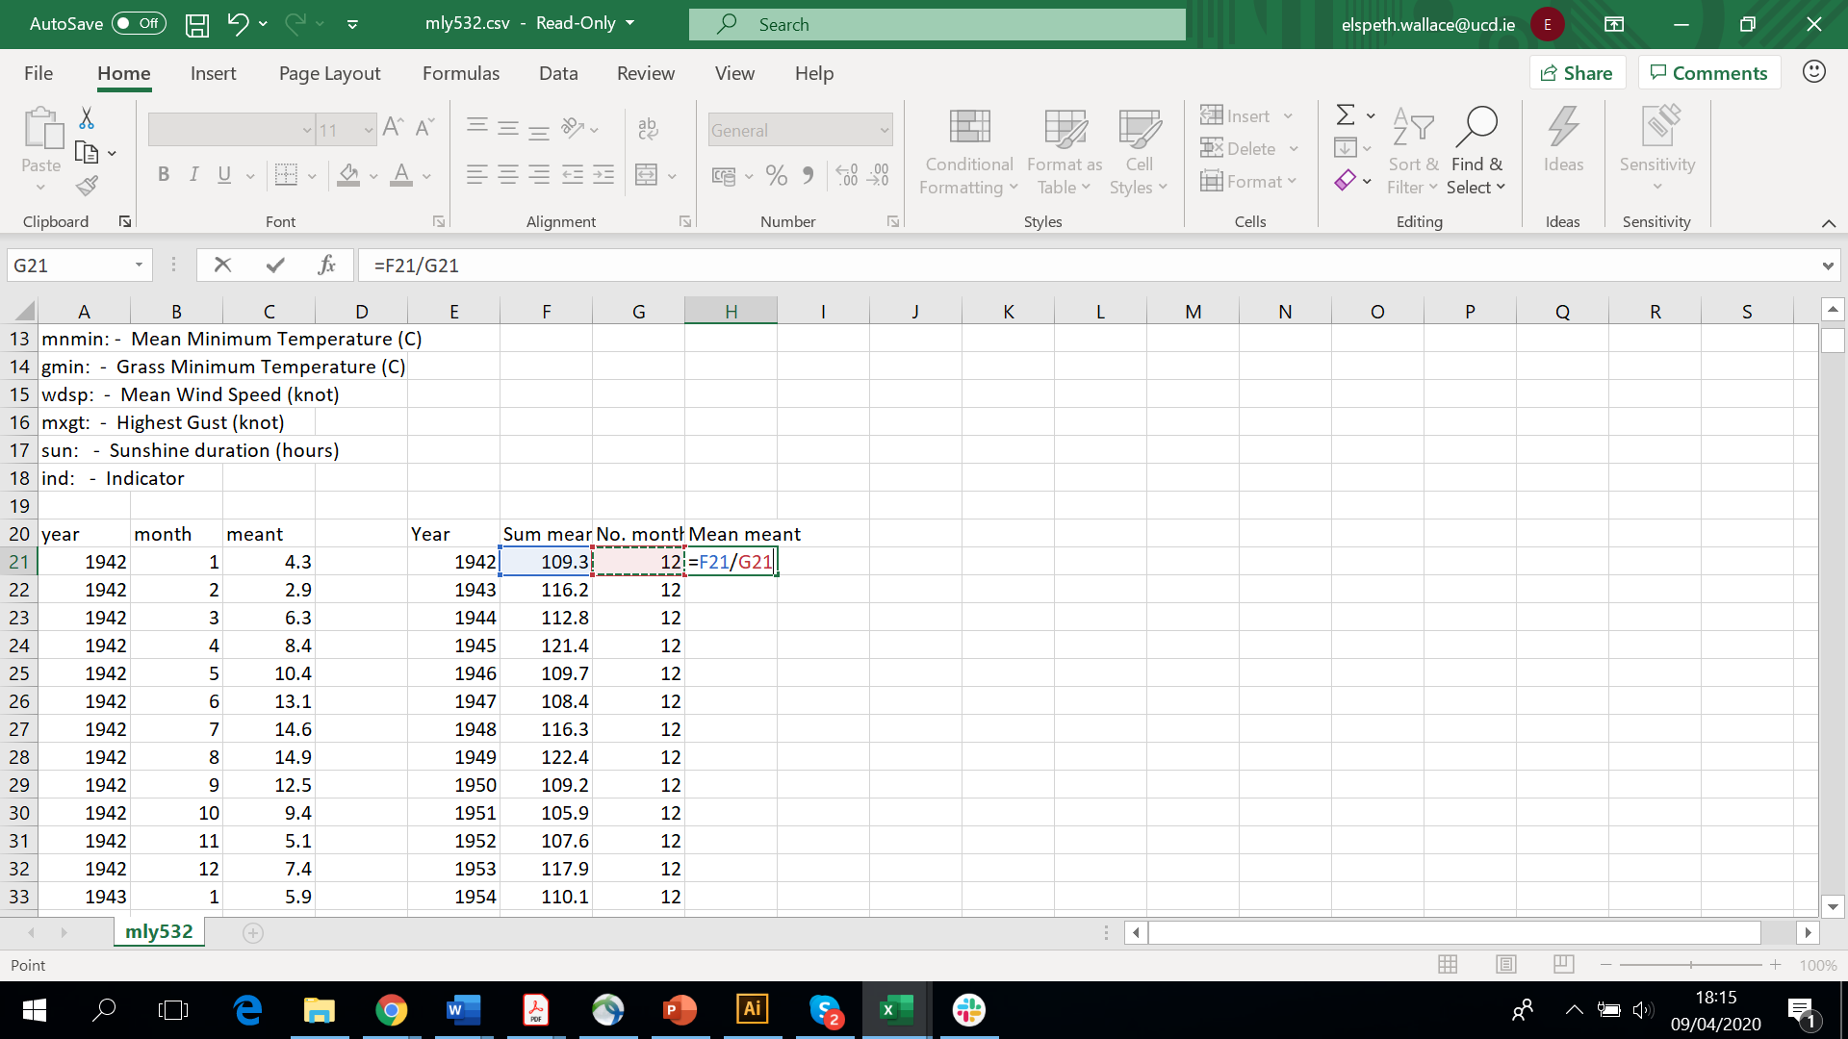
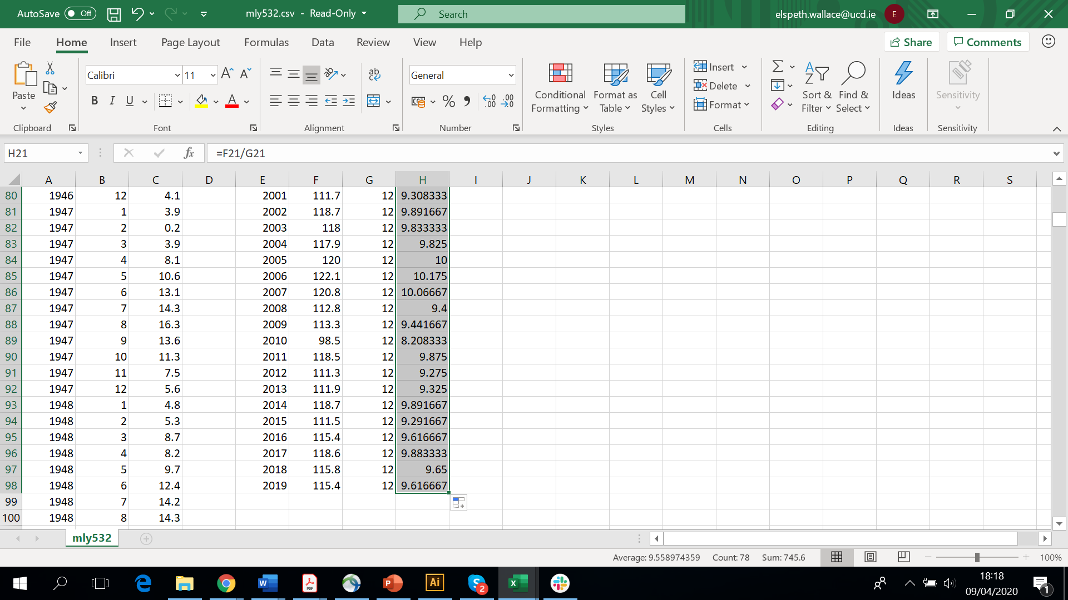

Congratulations! You’ve now worked out the yearly averages! There’s only one more formula to use before we introduce colour into the mix!
Remember that 30 year average we found earlier? Now we need to use it! We’re going to work out how different the yearly means we’ve just calculated are from the 30 year average.
Lets put in another two columns onto our spreadsheet:
30 Y Average | Difference between mean and 30 Y Av

In the 30Y Average column, enter the 30 year average value for the climatic variable you’re looking at, in our case for mean temperature this value is 9.8. Use the fill handle to copy this down the column.
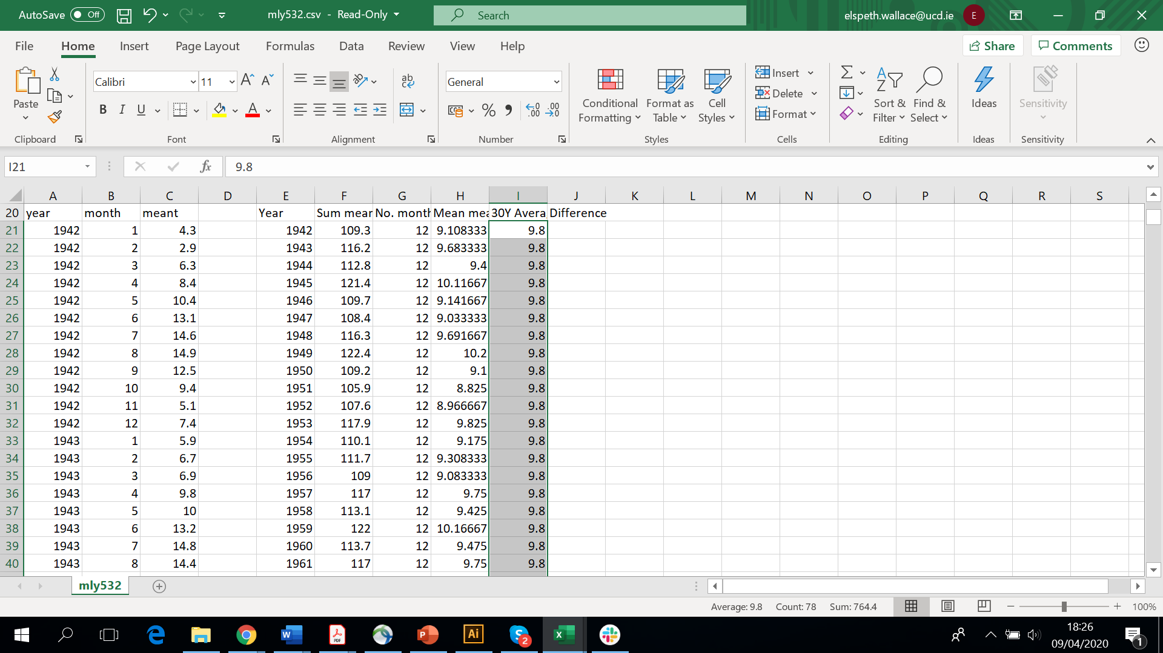
In the ‘Difference’ column we need to use one last formula. We need to minus the 30 year average from the mean ‘meant’ that we worked out. Input the formula =H21-I21 and press enter.
INPUT FORMULA HERE
Use the fill handle to copy this all the way down to the bottom.
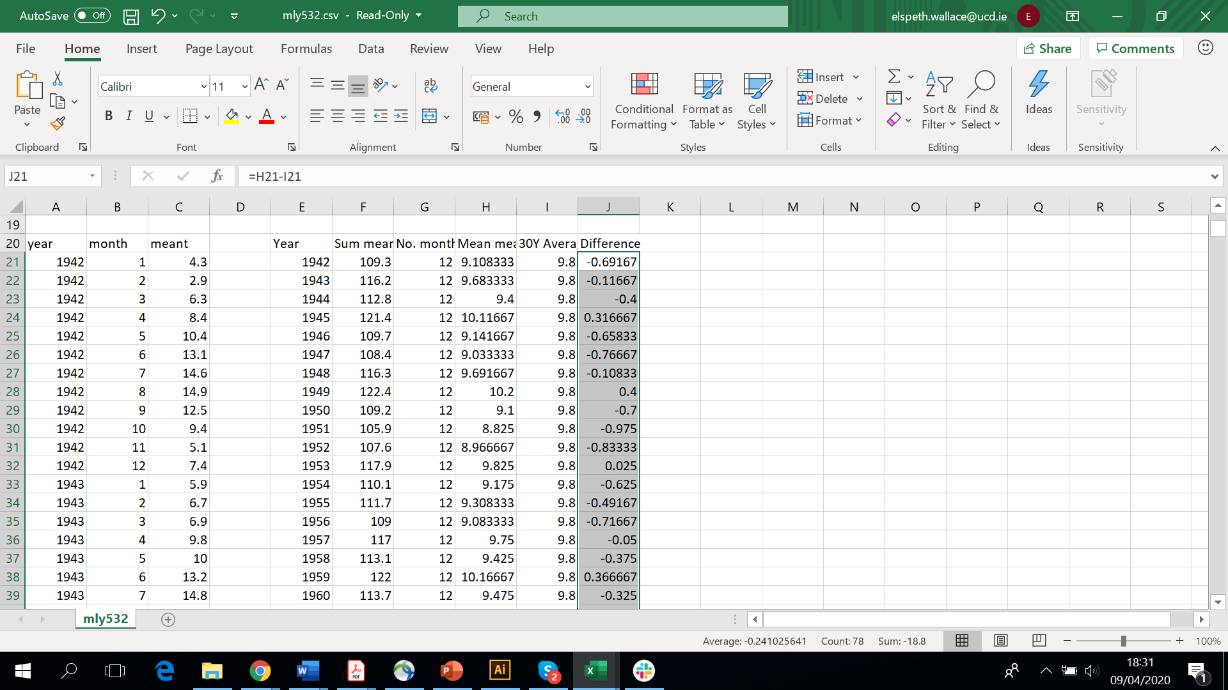
We’ve now finished step 2! It may have taken a little time, but it was well worth it! We know how much our yearly averages differ from the 30 year average and we can now introduce colour!
Step 3: Getting colourful
This step will vary for you depending on how many colours you have and how your data differs from the 30 year average for your chosen climatic variable. I’m going to use five colours for this example, but you can use as many or as few as you like (the more you use, the more complicated your pattern will be, the fewer you use, the more boring your pattern might look!).

First things first, we need to figure out what are lowest and highest values are. How much do our values vary from the 30 year average?
Find the lowest number (normally a negative number) and the highest number (normally a positive number) in your difference column and write these somewhere in your spreadsheet.
In our example these figures are:
Lowest: -1.6
Highest: 0.9
To work out what colours you use where, you need to work out the difference between your highest and lowest values and split this by the number of colours you have to create ranges.
My working looks like this:
Colour 1 (Navy) | Colour 2 (Blue) | Colour 3 (Cream) | Colour 4 (Yellow) | Colour 5 (Red)
-1.6 to -1.1 | -1.09 to -0.6 | -0.59 to -0.1 | -0.09 to 0.4 | 0.41 to 0.9

Now you can go back to your spreadsheet to assign colours to your years!
Let’s create one last column called Colour. In that column, you can write in the colour that corresponds to that value!
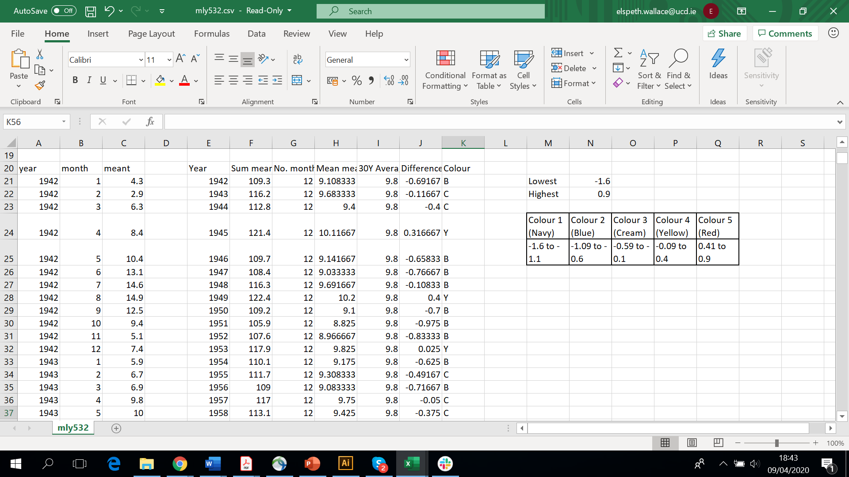
And that’s it! You’re done! You can use this pattern to create whatever you like! You can knit/crotchet/craft is exactly as it is, or use it to make something else, like a scarf, a jumper, a blanket, a tea cosy, whatever you fancy! How you make the pattern work is up to you, you can thicken the stripes to make it fit on your creation, or maybe repeat the pattern a few times. Its up to you!
Once you’ve finished your creation, remember to show us a picture! WE can’t wait to see what you create!
Happy crafting everyone!

